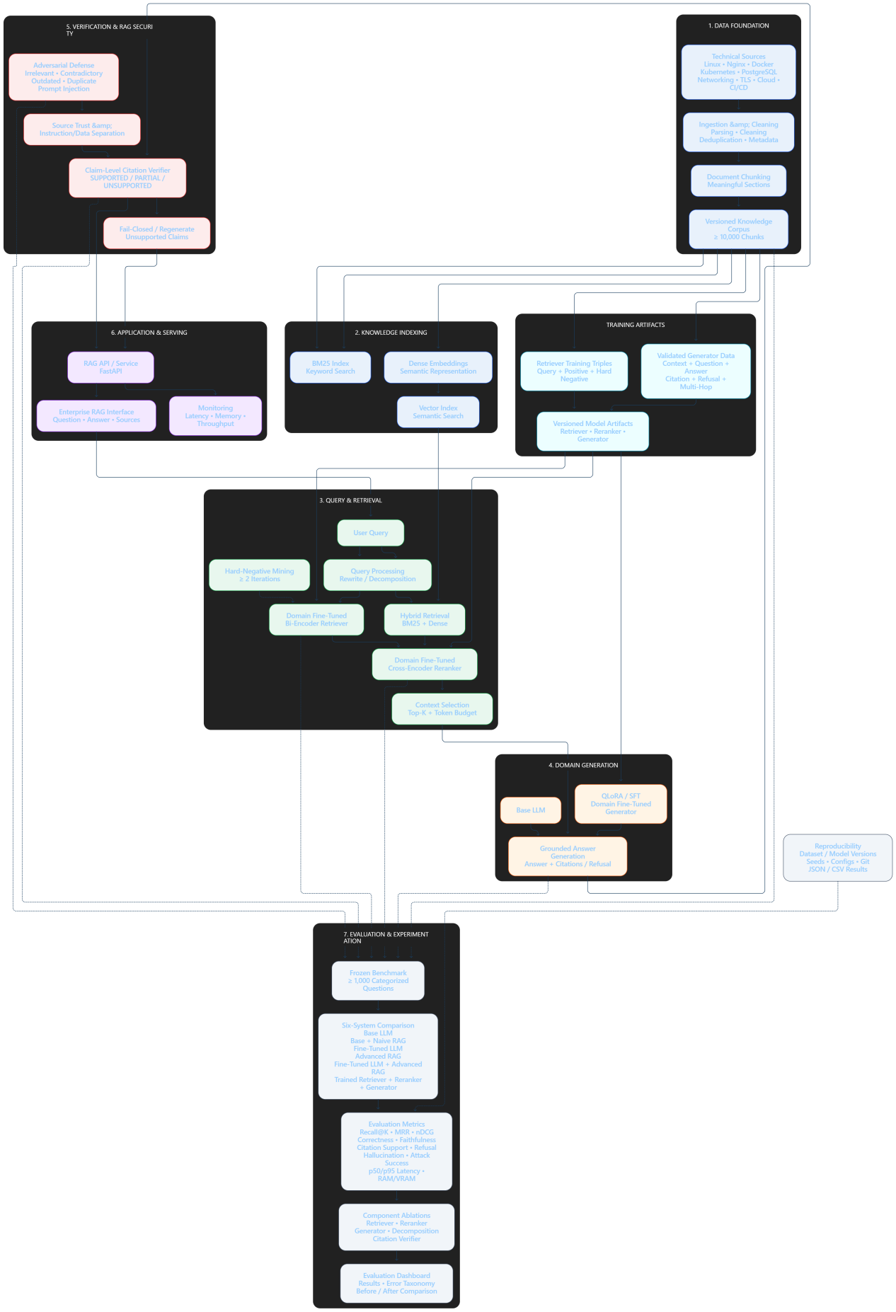
How this architecture should be understood
The diagram is essentially one big pipeline:
KNOWLEDGE
↓
┌──────────────────────┐
│ DATA FOUNDATION │
│ Corpus + Benchmark │
└──────────┬───────────┘
↓
┌──────────────────────┐
│ INDEXING │
│ BM25 + Vector Index │
└──────────┬───────────┘
↓
USER → QUERY → RETRIEVAL → RERANKING → CONTEXT
↓
DOMAIN GENERATOR
↓
CITATION VERIFIER
↓
SECURITY / REFUSAL
↓
FINAL ANSWER
The important part is that the project isn't just:
"Build a RAG chatbot."
It is:
Build a RAG system and systematically improve every important part of it, while measuring exactly what each improvement contributes.
Your research/evaluation layer therefore sits alongside the actual production pipeline rather than being part of the user's direct request path.

